**Make a new style.cs**

**1.** Go to File new and save this new file as style.css

**2.** Go back to index.html

**3.** Link the style sheet to the index page by adding a

<link rel="stylesheet" href="style.css" /> in the **head** area (not the header tag)

MAKE SURE YOU THE STYLE.CSS LINK IS AT THE BOTTOM OF THE HEAD- STYLE.CSS SHOULD BE THE LAST REFERENCE IN THE HEAD

We will start the styling at the top of the page and work our way down

**4.** (Bootstrap's global default font-size is 14px, with a line-height of 1.428. This is applied to the <body> element and all paragraphs ( <p> ). In addition, all <p> elements have a bottom margin that equals half their computed line-height (10px by default)

Accessibility guidelines suggest a font size of 16px so let’s add that to the body tag.

body{

font-size:16px;

font-family: arial, sans-serif;

}

**Styling the navbar**

**1.** As per the design comp we now need to add custom CSS to style the navbar

Go to the browser right click and go to Inspect Element, find the

<nav class="navbar navbar-inverse">

In the rules area in the browser inspector you will see that the background color and border are controlled by the navbar-inverse.

Lets remove that navbar-inverse class from index.html, and the navbar should be transparent

<nav class="navbar ~~navbar-inverse~~">

**2.** Now we change the font colour and size in the navbar.

Go to inspect element in the Browser and that blue colour for our links is coming from the Bootstrap global link ‘a’ class , lets change it to white. Our hover colour can be orange.

**2a.** So in styles.css add

.navbar{

font-size:0.875em;/\*since we have set the body font-size to 16px this can also be written as 1em, so if we want our navbar menu items to be smaller as per the design comp it needs to be less than 1em, the formula is 14(the size of the font in photoshop)divided by 16 which equals 0.875em\*/

}

**3.** All of our HREF links are blue we need them to be off- white so we can add a global selector that effects all ahref links

a{

color:#a99c9c ;

}

a:hover{

color: #ed7d1e;

}

**4.** We also don’t need Bootstrap’s hover background highlight blocks

.navbar-nav li a:hover {

background-color:transparent;

}

**5.** Make josh’s name larger as per the design comp

.navbar-brand {

font-size:2.5em; /\*41px(the size of the font in photoshop)divided by 16 which equals 2.5em\*/

font-weight: bolder;

letter-spacing: -3px;

}

**6.** In the HTML navbar-brand we can add a span that will control the colour of the text WHITKIN

<a class="navbar-brand" href="#"><span class="josh">JOSH</span><span class="orange">WHITKIN</span></a>

**7.** In the style.css add the orange class rule to change the colour of Whitkin with a span

.orange{

color:darkorange;

}

**8.** So in the style.css we need to add a rule to the existing .navbar class to remove the margin for

.navbar{

font-size:0.875em;

margin-bottom:0px;

}

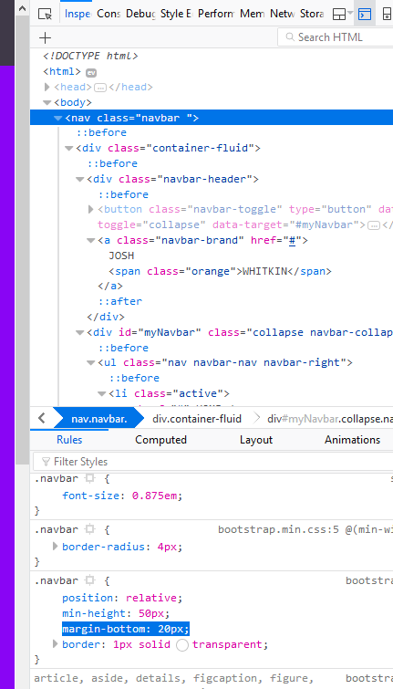

**9.** And we also need the mobile toggle at a small screen size to stand out more (we are about to add a background)

.navbar-toggle .icon-bar {

background-color: white;

}

**Styling the header**

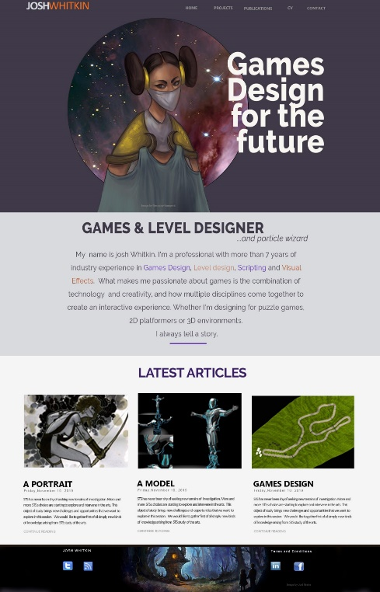

**1.** Add a custom class herobg to the header class

<header class="container-fluid herobg">

**2. Add the image to the header background**

a. From the Design comp get the layer with the header image in it

b. Make a marque around the whole image

c. Copy and paste into a new file

d. Save this image as a jpeg and in an images folder in Josh’s folder (make a new images folder for all your images)

**3.** Now add this rule to style.css

.herobg {

background: url("images/header-bg.jpg") no-repeat center center;

background-size: cover;/\*make the background image cover the whole div proportionally\*/

/\* do not pixel heights on divs- this is not responsive – instead padding on the children as a percentage\*/

}

Open index.html in the browser and we should have something like this

**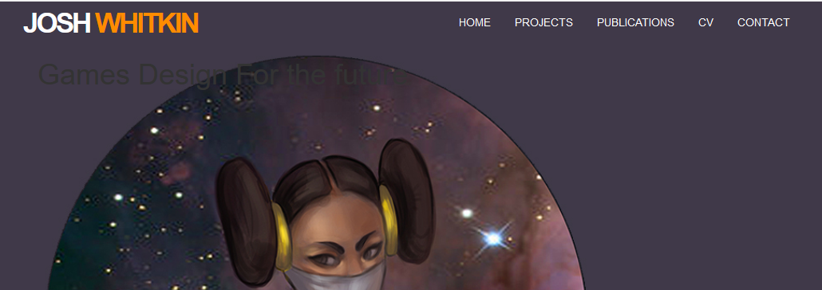**

**4.** Now we can add a descendent selector – herobg is the parent and H1 is the child within the parent.

In the CSS add this rule

.herobg h1{

float:right; /\* float the text to the right\*/

color:#ffff;/\* make the text white\*/

width:341px;/\* give the H1 a width so that we wrap the text as per the design comp\*/

font-size:7.125em; /\* 114px font size in photoshop divided by 16px= 7.125\*/

letter-spacing: -10px;/\* fix the letter-spacing\*/

font-weight: 800;/\* make the text bold\*/

line-height:75%;/\* decrease the line height\*/

margin-top:140px;/\* the words are 140px away from the navbar in photoshop\*/

text-align:right;

padding-bottom: 10%; /\* use a percentage so that we have a variable padding at the bottom – the children within the div should control the height of divs\*/

}

**5.** The header tag uses the Google font Raleway, we can call the font from Google to our webpage

Go to <https://fonts.google.com/specimen/Raleway>

Click on “Select this font” top right, hit family selected at the bottom of the page, we also need to customise to get the extrabold 800 size font as well

At the bottom of the webpage copy and paste the HTML and CSS

**6**. In the head of index.html add

<link href="https://fonts.googleapis.com/css?family=Raleway:400,800" rel="stylesheet">

**7.** In your .herobg h1 class add

font-family: 'Raleway', sans-serif;

The header section should now look like below

**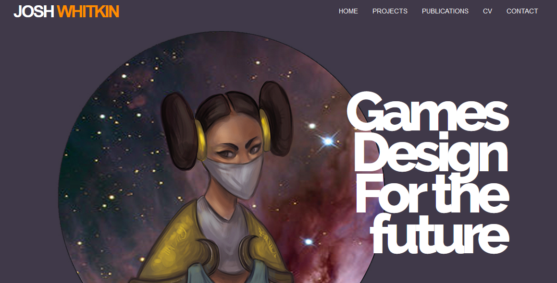**

**Style the ‘about me’ section**



**1.** We need to add a class to control the background of the container fluid-aboutbg

**2.** All of the text throughout this section is center aligned so we can add a Bootstrap class **text-center** to the html

**3** Add a html rule for the ampersand-&amp;

**4.** Add a class to change the -‘and particle wizard’

**5.** Add a class to change the paragraph text-- about-text

**6.** Add a div to make the small block that ends the paragraph - <div class="blocker"></div>

index.html

<section class="container-fluid aboutbg text-center">

<div class="container">

<h2> GAMES &amp; LEVEL DESIGNER </h2>

<p class="particle">...and particle wizard</p>

<p class="about-text">My name is josh Whitkin. I’m a professional with more than 7 years of industry experience in Games Design, Level design, Scripting and Visual Effects. What makes me passionate about games is the combination of technology and creativity, and how multiple disciplines come together to create an interactive experience. Whether I'm designing for puzzle games, 2D platformers or 3D environments. I always tell a story.</p>

<div class="blocker"></div>

</div>

</section>

**7.** In the style.css add these classes

.aboutbg{

background-color: #d9dade;

}

.aboutbg h2{

font-size:2.4em;

font-family: 'Raleway', sans-serif;

font-weight:800;

}

.particle {

text-align: right;

margin-right: 150px;

font-size: 1.5em;

font-style: italic;

font-weight: 400;

line-height: 0px;

padding-bottom: 40px;

}

.about-text{

margin-left:40px;

margin-right:40px;

font-size:1.8em;

line-height:2em;

font-family: 'Raleway', sans-serif;

}

.blocker {

width: 133px;

height: 10px;

background-color: purple;

margin: auto;

margin-bottom: 40px;

}

**Styling the article section**



Grab the article images from the design comp by;

1a. From the Design comp get the layer with the header image in it

1b. Make a marque around the whole image

1c. Copy and paste into a new file

1d. Save this image as a jpeg and in the images folder in Josh’s folder

**2.** Add the image to the top of the articles

<div class="col-md-4">

<img class="img-responsive" alt=“portait” src="images/portrait.jpg">

<h4>A PORTRAIT</h4>

<p >12 Dececmeber 2020</p>

<p>STS has never been shy of seeking new terrains of investigation. More and more STS s cholars are starting to explore and intervene in the arts. This object of study brings new challenges and opportunities that we want to explore in this session. We would like to gather first of all simply new kinds of knowledge arising from STS study of the arts.

</p>

<p >CONTINUE READING</p>

</div>

**3.** Add a class to the container-fluid to control the background colour- articlesbg

<section class="container-fluid articlesbg">

**4.** And in style.css add the rule  
.articlesbg{  
 background-color: #f5f5f5;

}

**5.** Add a class article-title to the title of the articles, we can also center the text in the div by using the text-center Bootstrap class

<div class="article-title text-center">

<h3>LATEST ARTICLES</h3>

</div>

**6.** And in style.css add the rule

.article-title h3{

font-size:2.0em;

font-family: 'Raleway', sans-serif;

font-weight:800;

color:#3c1f68;

}

**7.** Each of the 3 article sections will use reusable classes, so just repeat these classes in the other 2 sections

<div class="col-md-4">

<img class="img-responsive" alt=“portait” src="images/portrait.jpg">

<h4>A PORTRAIT</h4>

<p class="date">12 December 2020</p>

<p>STS has never been shy of seeking new terrains of investigation. More and more STS s cholars are starting to explore and intervene in the arts. This object of study brings new challenges and opportunities that we want to explore in this session. We would like to gather first of all simply new kinds of knowledge arising from STS study of the arts.

</p>

<p class="readmore">CONTINUE READING</p>

</div>

**8.** And in style.css add the rules

h4 {

font-size: 1.6em;

font-family: raleway;

font-weight: 400;

}

.date{

letter-spacing: 2px;

font-size: 0.8em;

}

.readmore{

color: #a19ba6;

font-size: 0.9em;

margin-bottom: 30px;

}

**Styling the footer**

**1.** Grab the image for the footerbackground

a. From the Design comp get the layer with the footer image in it

b. Make a marque around the whole image

c. Copy and paste into a new file

d. Save this image as a jpeg and in an images folder in Josh’s folder (make a new images folder for all your images)

Add the images to the footer in index.html

<img src="images/linkedin.jpg" alt=“linkedin” >

<img src="images/fb.jpg” alt=“facebook” >

**2.** We need to a rule to add an image to the background of the footer, but we only have one footer so we can just use footer as the style rule

Add this rule to style.css

footer{

background-image:url(images/footer-bg.jpg);

background-size:cover;

width:100%;

background-position: center center;

}

We need to change the styling for the content

**3.** Add a footer content class that we can reuse for both sides- footer-content

**4.** We can also centre all the content in the columns with the Bootstrap class text-centre

<footer class="container-fluid">

<div class="container">

<div class="row">

<div class="col-md-6 text-center footer-content">

<p>JOSH WHITKIN</p>

<img src="images/tumblr.jpg" alt=“tumblr” >

<img src="images/rss.jpg" alt=“rss” >

</div>

<div class="col-md-6 text-center footer-content">

<p>Terms and Conditions</p>

<img src="images/linkedin.jpg" alt=“linkedin” >

<img src="images/fb.jpg” alt=“facebook” ">

</div>

</div>

</div>

</footer>

**5.** Add this rule in style.css

.footer-content{

margin-top: 30px;

margin-bottom:30px;

color:white;

}

**Well done your page should look like this!**



**Making the page responsive by adding media queries**

**1.** Go to file new and save the file as responsive.css

**2**. Link the responsive.css to our index.html- add the red code to the head

<!DOCTYPE html>

<html lang="en">

<head>

<meta charset="utf-8">

<meta http-equiv="X-UA-Compatible" content="IE=edge">

<meta name="viewport" content="width=device-width, initial-scale=1">

<!-- The above 3 meta tags \*must\* come first in the head; any other head content must come \*after\* these tags -->

<title>JOSH WHITKIN</title>

<!-- Bootstrap -->

<link href="css/bootstrap.min.css" rel="stylesheet">

<!-- HTML5 shim and Respond.js for IE8 support of HTML5 elements and media queries -->

<!-- WARNING: Respond.js doesn't work if you view the page via file:// -->

<!--[if lt IE 9]>

<script src="https://oss.maxcdn.com/html5shiv/3.7.3/html5shiv.min.js"></script>

<script src="https://oss.maxcdn.com/respond/1.4.2/respond.min.js"></script>

<![endif]-->

<link rel="stylesheet" href="style.css" />

<link rel="stylesheet" href="responsive.css" />

<link href="https://fonts.googleapis.com/css?family=Raleway:400,800&display=swap" rel="stylesheet">

</head>

**2.** We also now need to control the styling in the article columns we need to add a class

<div class="col-md-4 article-cent">

**3.** When the page collapses the article’s content site on the right- lets centre the text and images

@media only screen and (max-width: 990px) {

.article-cent{

text-align:center;

}

.article-cent img{

margin: auto;

}

}

3. At about 700px width the main tag crosses over the girls face, add this rule to responsive.css

@media only screen and (max-width: 700px) {

.herobg h1{

float:none; /\*remove the float- that pushed the text to the right\*/

width:100%;

/\* make the text fill the whole width\*/

text-align:center;

/\* center align the text\*/

margin-top: 60%; /\* push the text down using 60% of the widht of the browser- this will always adjust according to width of screen\*/

font-size: 5.125em;

/\* reduce the size of font\*/

}

}

At about 500px the aboutme text becomes to big and the particle text needs to be moved as well.

Add these rules to responsive.css

@media only screen and (max-width: 500px) {

.particle {

text-align: center;

margin-right: 0px;

}

.about-text {

margin-left: 0px;

margin-right: 0px;

font-size: 1.0em;

}

}



**Now Validate the html and CSS**

**1.** Copy and paste all the html code from index.html page into

<https://validator.w3.org/#validate_by_input>

and validate.

You should haveno errors- if you do fix them now. Errors in HTML are like snowballs, better to catch at this early stage before they turn into an avalanche when you convert this code into php and Wordpress.

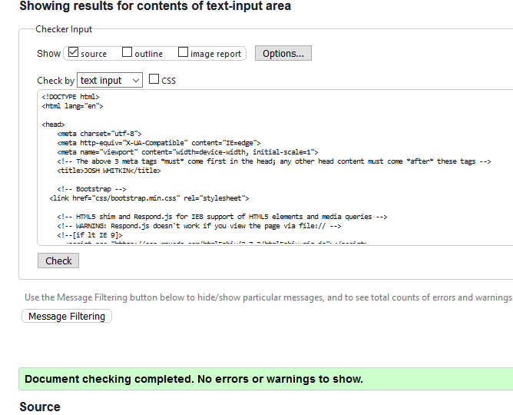

**2.** Copy and paste your style.css into

[https://jigsaw.w3.org/css-validator/#validate\_by\_input](https://jigsaw.w3.org/css-validator/" \l "validate_by_input)

Validate your code

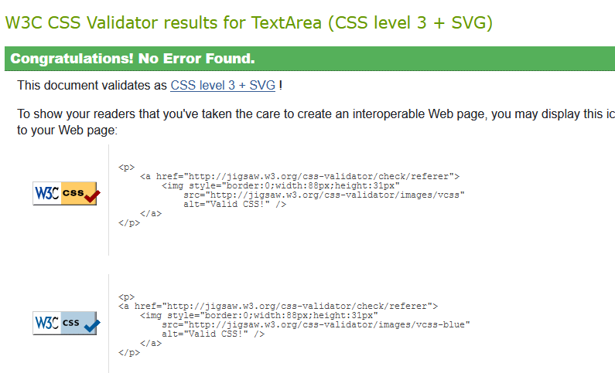

*PROBLEMS?*

*If some of the DIV’s do not get smaller then you probably have not converted the heights of the divs to percentages- or you have not removed the fixed pixel height.*

*All large fixed pixel width, heights, paddings or margins need to be converted to a dynamic measure- usually a percentage—or your page will not be responsive.*

*It is important that your HTML and CSS is perfect, because the HTML and CSS will be harder to fix when we convert the code into PHP*

**3.** NOW use Github desktop to PUSH YOUR local files to your online Github repository.

You should also watch the rest of the “How to use Github” in week 1 on LMS. We will be using Github Desktop for Wordpress as well.

WELL DONE!

for completing the HTML version

WORDPRESS HERE WE COME